Project Details:
Website Name: BetFlow Systems

Logo (svg):
Database ERD:
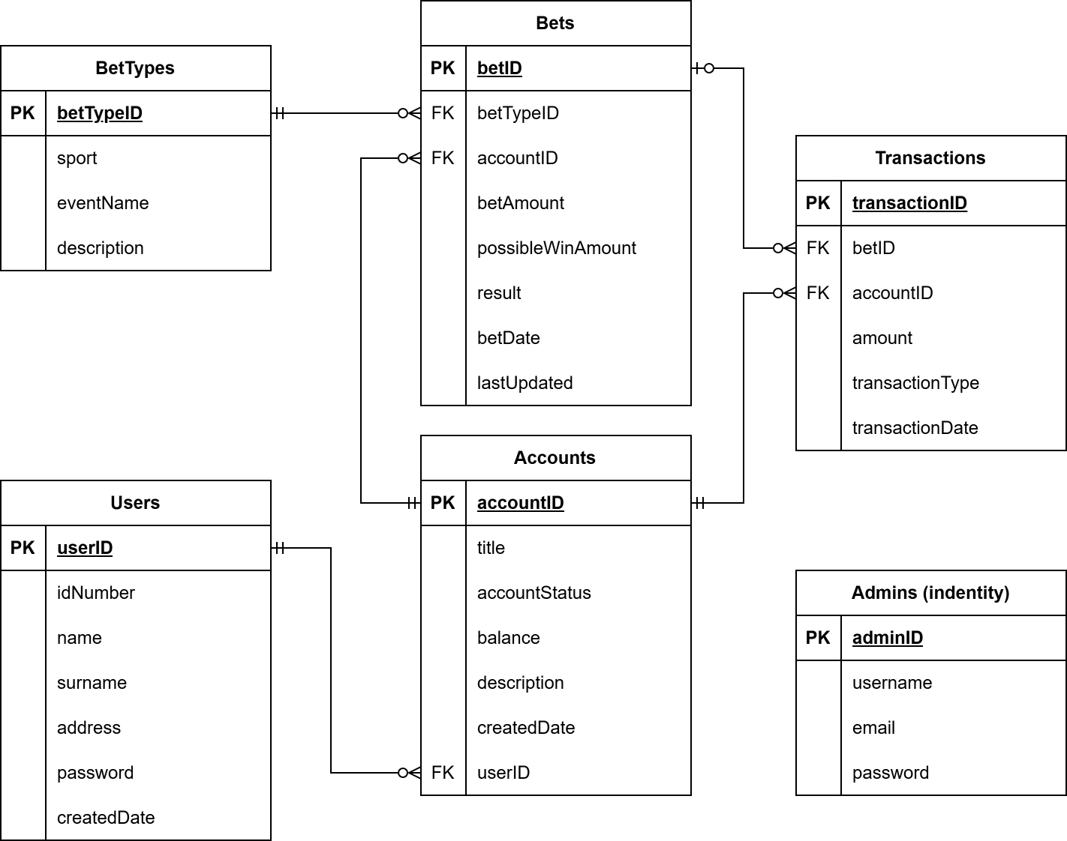
DB Constraints.
0) Admin – Managed by Identity

1) Users Table
Table Name: Users
Primary Key
- UserID → Primary Key
Column Constraints
- IdNumber
  - Required
  - Maximum length: 13
  - Unique index enforced
- IsActive
  - Required
  - Default value: true
- Name
  - Required
  - Maximum length: 50
- Surname
  - Required
  - Maximum length: 50
- Address
  - Maximum length: 200
  - Not explicitly marked as required in Fluent API
- CreatedDate
  - Required
  - Default value: GETDATE()
Indexes
- Unique index on IdNumber
Relationships
- One User can have many Accounts
- Foreign key handled in Accounts.UserID
Delete Behavior
- Deleting a User will cascade delete related Accounts

2) Accounts Table
Table Name: Accounts
Primary Key
- AccountID → Primary Key
Column Constraints
- AccountStatus
  - Required
  - Stored as string
  - Maximum length: 20
- Title
  - Required
  - Maximum length: 50
- Balance
  - Required
  - SQL type: decimal(18,2)
- Description
  - Optional
  - Maximum length: 200
- CreatedDate
  - Required
  - Default value: GETDATE()
- UserID
  - Required
  - Foreign key to Users(UserID)
Relationships
- Many Accounts belong to one User
- One Account can have many Bets
- One Account can have many Transactions
Foreign Key Constraints
- UserID → Users(UserID)
Delete Behavior
- If a User is deleted, related Accounts are cascade deleted

3) BetTypes Table
Table Name: BetTypes
Primary Key
- BetTypeID → Primary Key
Column Constraints
- Sport
  - Required
  - Maximum length: 30
- EventName
  - Required
  - Maximum length: 50
- Description
  - Optional
  - Maximum length: 255
Relationships
- One BetType can have many Bets
Delete Behavior
- BetType deletion is restricted if referenced by any Bet

4) Bets Table
Table Name: Bets
Primary Key
- BetID → Primary Key
Column Constraints
- AccountID
  - Optional
  - Foreign key to Accounts(AccountID)
- BetTypeID
  - Required
  - Foreign key to BetTypes(BetTypeID)
- BetAmount
  - Required
  - SQL type: decimal(18,2)
- PossibleWinAmount
  - Required
  - SQL type: decimal(18,2)
- Result
  - Required
  - Stored as string
  - Maximum length: 20
- BetDate
  - Required
  - Default value: GETDATE()
- LastUpdatedDate
  - Required
  - Default value: GETDATE()
Relationships
- Many Bets can belong to one Account
- Many Bets belong to one BetType
- One Bet can have many Transactions
Foreign Key Constraints
- AccountID → Accounts(AccountID)
- BetTypeID → BetTypes(BetTypeID)
Delete Behavior
- If an Account is deleted, Bets.AccountID is set to NULL
- If a BetType is referenced by any Bet, deletion is restricted

5) Transactions Table
Table Name: Transactions
Primary Key
- TransactionID → Primary Key
Column Constraints
- AccountID
  - Optional
  - Foreign key to Accounts(AccountID)
- BetID
  - Required
  - Foreign key to Bets(BetID)
- Amount
  - Required
  - SQL type: decimal(18,2)
- TransactionType
  - Required
  - Stored as string
  - Maximum length: 20
- TransactionDate
  - Required
  - Default value: GETDATE()
Relationships
- Many Transactions can belong to one Account
- Many Transactions belong to one Bet
Foreign Key Constraints
- AccountID → Accounts(AccountID)
- BetID → Bets(BetID)
Delete Behavior
- If an Account is deleted, Transactions.AccountID is set to NULL
- If a Bet is referenced by a Transaction, deletion is restricted

Enum Storage Rules
The following enum properties are stored as strings in the database:
- Accounts.AccountStatus
  - Stored as string
  - Max length: 20
- Bets.Result
  - Stored as string
  - Max length: 20
- Transactions.TransactionType
  - Stored as string
  - Max length: 20
This improves readability in the database compared to integer enum storage.

Relationship Summary
User → Account
- One-to-Many
- FK: Accounts.UserID
- Delete behavior: Cascade
Account → Bet
- One-to-Many
- FK: Bets.AccountID
- Delete behavior: Set NULL
BetType → Bet
- One-to-Many
- FK: Bets.BetTypeID
- Delete behavior: Restrict
Account → Transaction
- One-to-Many
- FK: Transactions.AccountID
- Delete behavior: Set NULL
Bet → Transaction
- One-to-Many
- FK: Transactions.BetID
- Delete behavior: Restrict

Documentation-Friendly Constraint Matrix
Users
- PK: UserID
- Unique: IdNumber
- Required: IdNumber, IsActive, Name, Surname, CreatedDate
- Defaults:
  - IsActive = true
  - CreatedDate = GETDATE()
Accounts
- PK: AccountID
- FK: UserID → Users(UserID)
- Required: AccountStatus, Title, Balance, CreatedDate, UserID
- Defaults:
  - CreatedDate = GETDATE()
BetTypes
- PK: BetTypeID
- Required: Sport, EventName
Bets
- PK: BetID
- FK:
  - AccountID → Accounts(AccountID)
  - BetTypeID → BetTypes(BetTypeID)
- Required:
  - BetTypeID
  - BetAmount
  - PossibleWinAmount
  - Result
  - BetDate
  - LastUpdatedDate
- Defaults:
  - BetDate = GETDATE()
  - LastUpdatedDate = GETDATE()
Transactions
- PK: TransactionID
- FK:
  - AccountID → Accounts(AccountID)
  - BetID → Bets(BetID)
- Required:
  - BetID
  - Amount
  - TransactionType
  - TransactionDate
- Defaults:
  - TransactionDate = GETDATE()

